**ASSIGNMENT-1.4**

**Course: AI Assisted Coding**

**Name: B. Divya Sri**

**HT NO: 2403A51425**

**Batch- 16**

**#Task 1:**

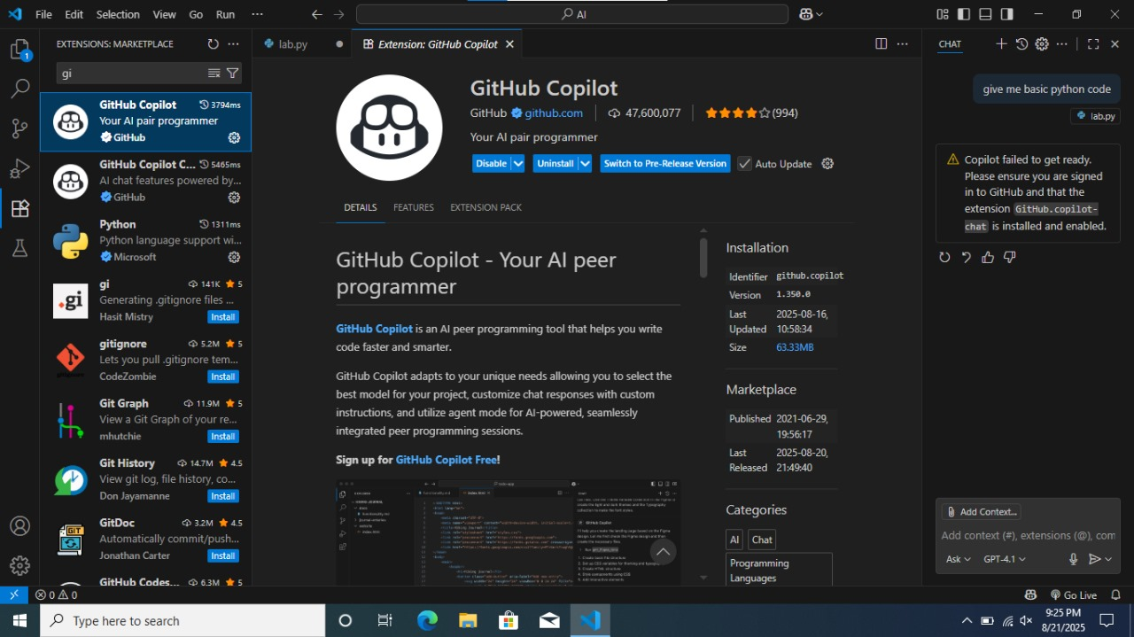

**#Task 2:**

**Prompt:**

Write a program in python that returns the maximum of three numbers using function by taking user input.

**Code:**

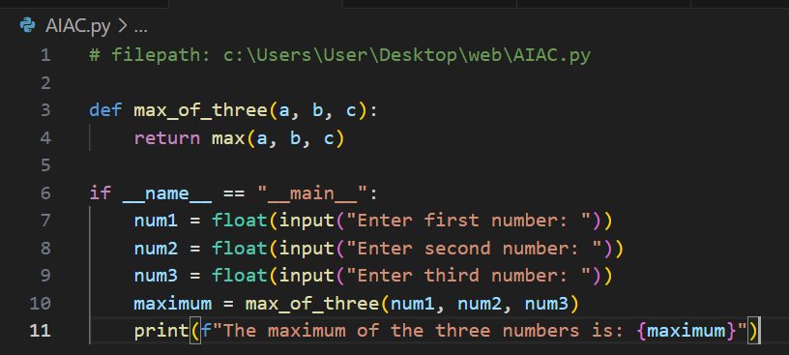

**Output:**

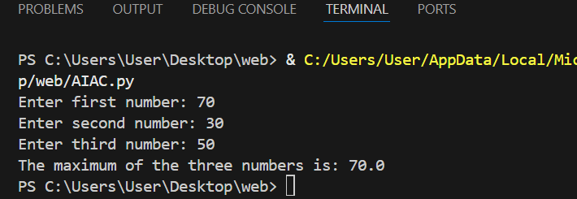

**Explanation:**

* The function [max_of_three(a, b, c)](vscode-file://vscode-app/c:/Users/User/AppData/Local/Programs/Microsoft%20VS%20Code/resources/app/out/vs/code/electron-browser/workbench/workbench.html) takes three arguments and returns the largest one using Python’s built-in [max()](vscode-file://vscode-app/c:/Users/User/AppData/Local/Programs/Microsoft%20VS%20Code/resources/app/out/vs/code/electron-browser/workbench/workbench.html) function.
* **Main Program:**  
  When you run the script directly (not importing it as a module), it:
  1. Asks the user to enter three numbers (using [input()](vscode-file://vscode-app/c:/Users/User/AppData/Local/Programs/Microsoft%20VS%20Code/resources/app/out/vs/code/electron-browser/workbench/workbench.html)).
  2. Converts those inputs to floating-point numbers with [float()](vscode-file://vscode-app/c:/Users/User/AppData/Local/Programs/Microsoft%20VS%20Code/resources/app/out/vs/code/electron-browser/workbench/workbench.html).
  3. Calls [max_of_three()](vscode-file://vscode-app/c:/Users/User/AppData/Local/Programs/Microsoft%20VS%20Code/resources/app/out/vs/code/electron-browser/workbench/workbench.html) with those numbers to find the largest.
  4. Prints out the largest number.

**Key points:**

* [if __name__ == "__main__":](vscode-file://vscode-app/c:/Users/User/AppData/Local/Programs/Microsoft%20VS%20Code/resources/app/out/vs/code/electron-browser/workbench/workbench.html) ensures the code only runs when the file is executed directly.
* [input()](vscode-file://vscode-app/c:/Users/User/AppData/Local/Programs/Microsoft%20VS%20Code/resources/app/out/vs/code/electron-browser/workbench/workbench.html) always returns a string, so [float()](vscode-file://vscode-app/c:/Users/User/AppData/Local/Programs/Microsoft%20VS%20Code/resources/app/out/vs/code/electron-browser/workbench/workbench.html) is used to convert it to a number.
* [max()](vscode-file://vscode-app/c:/Users/User/AppData/Local/Programs/Microsoft%20VS%20Code/resources/app/out/vs/code/electron-browser/workbench/workbench.html) is a built-in function that returns the largest of its arguments.

**#Task 3:**

**Prompt:**

write a program in python that calculates the factorial of a number using recursive function.Take input from the user.

**Code:**

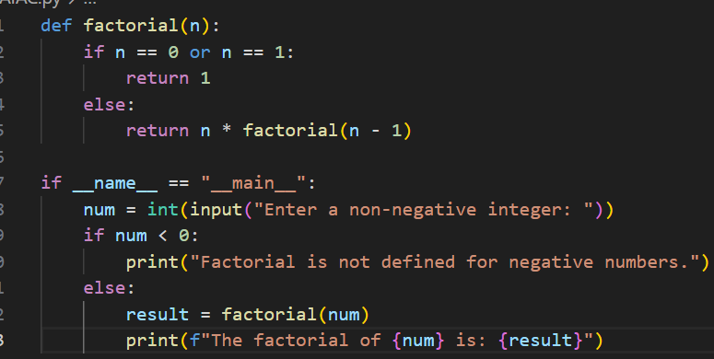

**Output:**

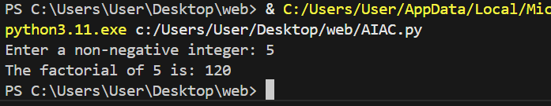

**Explanation:**

* **factorial(n):**  
  This is a function that calculates the factorial of a number [n](vscode-file://vscode-app/c:/Users/User/AppData/Local/Programs/Microsoft%20VS%20Code/resources/app/out/vs/code/electron-browser/workbench/workbench.html) using recursion.
  + If [n](vscode-file://vscode-app/c:/Users/User/AppData/Local/Programs/Microsoft%20VS%20Code/resources/app/out/vs/code/electron-browser/workbench/workbench.html) is 0 or 1, it returns 1 (because 0! and 1! are both 1).
  + Otherwise, it multiplies [n](vscode-file://vscode-app/c:/Users/User/AppData/Local/Programs/Microsoft%20VS%20Code/resources/app/out/vs/code/electron-browser/workbench/workbench.html) by the factorial of [n-1](vscode-file://vscode-app/c:/Users/User/AppData/Local/Programs/Microsoft%20VS%20Code/resources/app/out/vs/code/electron-browser/workbench/workbench.html).
* **Main Program:**
  + It asks the user to enter a non-negative integer.
  + If the number is negative, it prints a message saying factorial is not defined for negative numbers.
  + If the number is 0 or positive, it calculates the factorial using the function and prints the result.

**#Task 4:**

**Prompt:**

Write a program in python to create a class named Student with attributes name, roll_no, and  
marks and display student details.

**Code:**

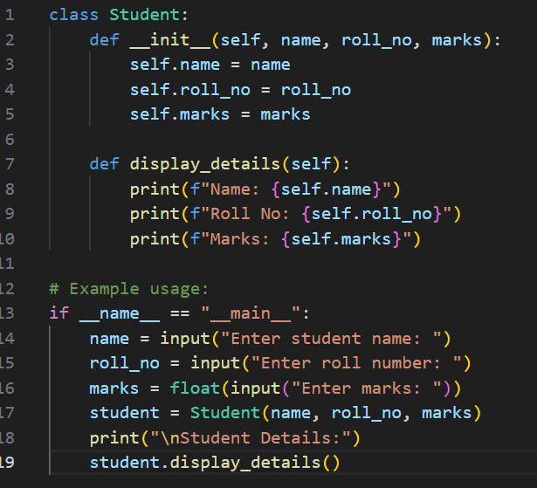

**Output:**

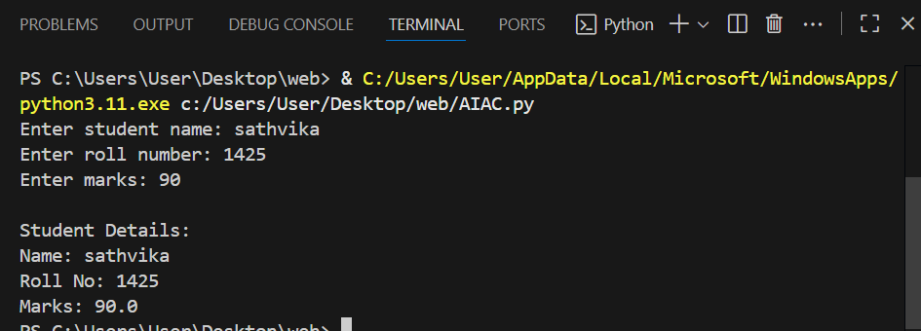

**Explanation:**

* **Student class:**  
  This class has three attributes: [name](vscode-file://vscode-app/c:/Users/User/AppData/Local/Programs/Microsoft%20VS%20Code/resources/app/out/vs/code/electron-browser/workbench/workbench.html), [roll_no](vscode-file://vscode-app/c:/Users/User/AppData/Local/Programs/Microsoft%20VS%20Code/resources/app/out/vs/code/electron-browser/workbench/workbench.html), and [marks](vscode-file://vscode-app/c:/Users/User/AppData/Local/Programs/Microsoft%20VS%20Code/resources/app/out/vs/code/electron-browser/workbench/workbench.html).  
  When you create a Student object, you give values for these attributes.
* **display_details method:**  
  This method prints out the student's name, roll number, and marks.
* **Main program:**  
  The program asks the user to enter a student's name, roll number, and marks.  
  It then creates a Student object with this information and displays the details using the [display_details](vscode-file://vscode-app/c:/Users/User/AppData/Local/Programs/Microsoft%20VS%20Code/resources/app/out/vs/code/electron-browser/workbench/workbench.html) method.

**#Task 5:**

**Prompt:**

write a program in python that takes string as input and returns the frequency of each word.

**Code:**

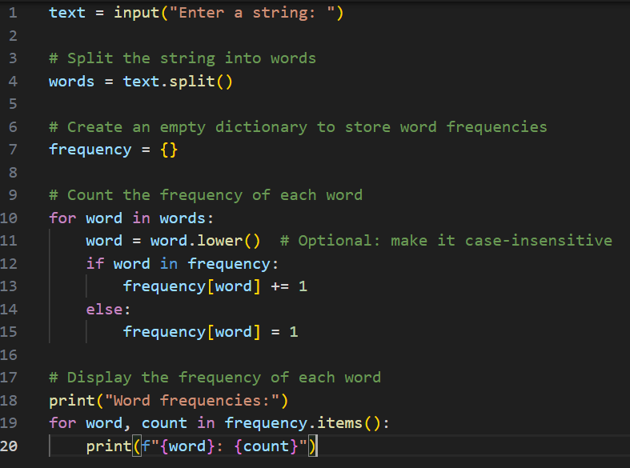

**Output:**

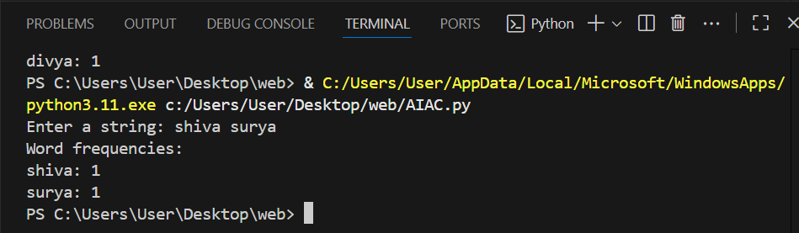

**Explanation:**

* The program asks the user to enter a string.
* It splits the string into words.
* It creates an empty dictionary to keep track of how many times each word appears.
* For each word, it converts it to lowercase (so "The" and "the" are counted as the same word).
* It counts how many times each word appears in the string.
* Finally, it prints each word and its frequency.